Assignment 2

# Display the details from Customer table who is from country Germany

--1

update Customer set Country='Germany' where id in (2,4);

select * from Customer where Country='Germany';

# Display the full name of the employee

--2

Select CONCAT(FirstName,' ',LastName) as 'Full Name' from Customer;

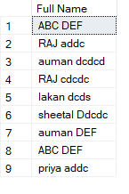

# Display the customer details who has Fax number

--3

ALTER TABLE Customer ADD FaxNumber nvarchar(20);

update Customer set FaxNumber='12355' where id in(1,4,6);

SELECT * from Customer Where FaxNumber is not Null;

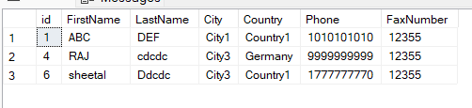

# display the customer details whose name holds second letter as U

--4

update Customer set FirstName='auman' where id in (3,7);

Select * from Customer where FirstName like '_u%';

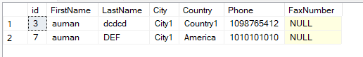

# select order Details where unit price is greater than 10 and less than 20

--5

select * from Orders inner join OrderItem on (Orders.id=OrderItem.Orderid) where OrderItem.UnitPrice between 10 and 20;

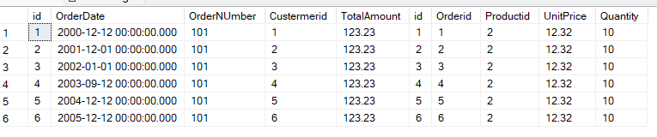

# Display order details which contains shipping date and arrange the order by date

--6

select * from Orders order by OrderDate;

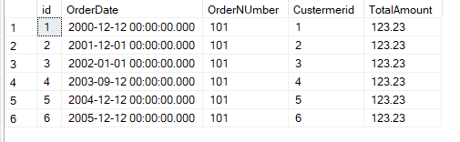

# Print the orders shipped by ship name 'La corned'abondance' between 2 dates(Choose dates of your choice)

--7 n 10 table

create table ShippingDetails(

ship_id int primary key,

reference_number varchar(30) NOT NULL,

shipping_date datetime NOT NULL,

ship_name varchar(20),

is_operating binary,

Shipping_Comapany varchar(20),

order_id int FOREIGN KEY REFERENCES Orders(id)

);

insert into ShippingDetails values

(121,'1233','2002-12-12',concat('La corned',char(39),'abondance'),1,'company 1 ',1),

(122,'1243','2001-12-12',concat('La corned',char(39),'abondance'),0,'company2',2),

(123,'1233','2005-12-12',concat('La corned',char(39),'abondance'),1,'company3',3);

--7

Select * from orders where id in (select order_id from ShippingDetails where (ship_name=concat('La corned',char(39),'abondance'))

and Shipping_date between '2000-12-12' and '2002-12-12');

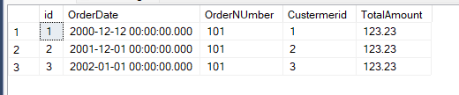

# Print the products supplied by 'Exotic Liquids'

--8

create table product_supply

(prod_id int , order_id int ,prod_name varchar(30),categoryname varchar(30),price decimal, discount decimal,supplier_name varchar(50) );

insert into product_supply values(1555, 4455,'prod_1','seafood',450.3, 10.2, 'fleshyfoods')

insert into product_supply values(1556, 4456,'prod_2','chinese',452.3, 10.2, 'flycurry')

insert into product_supply values(1557, 4457,'prod_3','coco-cola',455.3, 10.2, 'exotic liquids')

insert into product_supply values(1558, 4458,'prod_4','limca',420.3, 10.2, 'exotic liquids')

select *from product_supply where supplier_name='exotic liquids'

alter table product_supply add availability_status varchar(40)

update product_supply set availability_status='out of stock' where supplier_name='exotic liquids'

select * from product_supply where supplier_name='exotic liquids'

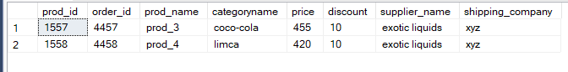

# Print the average quantity ordered for every product

--9

select ProductID,avg(Quantity) as AVERAGE from OrderItem group by Productid;

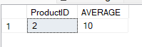

# Print all the Shipping company name and the ship names if they are operational

--10

Select Shipping_Comapany ,ship_name from ShippingDetails where is_operating=1;

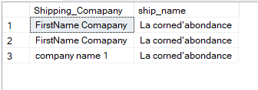

# Print all Employees with Manager Name

create table employee

(EmpID int primary key,

Fname varchar (50),

title varchar (50),

managerID int,

salary int,

rating int,

depid int FOREIGN KEY REFERENCES department(id)

);

create table department(

id int primary key,

Dname varchar (50),

);

insert into department values(1,'it'),(2,'sales');

insert into employee values (1,'Name1','manager',null,null,4,1),

(2,'Name2',null,1,null,4,1),

(3,'Name3',null,1,null,4,1),

(4,'Name4','manager',null,null,4,2),

(5,'Name5',null,4,null,4,1);

--11

select e1.Fname,e2.Fname as 'manager' from employee as e1 join employee as e2 on e1.managerID=e2.EmpID;

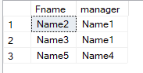

# Print the bill for a given order id .bill should contain Productname, Categoryname,price after discount

--12

select prod_name, categoryname, (price-discount ) as bill_amount from product_supply where order_id='4455';



# Print the Total price of orders which have the products supplied by 'Exotic Liquids' if the price is > 50 and also print it by Shipping company's Name

--13

alter table product_supply add shipping_company varchar(40);

update product_supply set shipping_company='xyz' where supplier_name='exotic liquids';

select sum(price) as 'Total_price' from product_supply where supplier_name='exotic liquids'

